Sunday | Monday | Tuesday | Wednesday | Thursday | Friday | Saturday
19  Outside  Get some fresh air. Take a walk, skip, run, ride your bike or play outside!   | 20  Leg Muscles  8 forward lunges  8 squats  8 squat jumps  Repeat  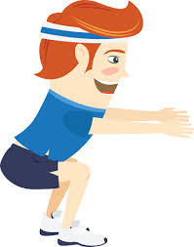 | 21  Core Muscles  8-12 crunches  15-30 second front plank  8-12 mountain climbers  Repeat  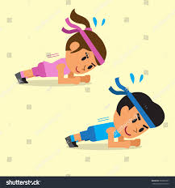 | 22  Cardio Day!  15-30 jumping jacks  30 second run in place  15 second Jump rope OR mountain climbers  Repeat   | 23  Upper Body Muscles  (Chest, Arms, Shoulders)  6-12 pushups  30 second arm circles  30 second shoulder shrugs  30 second neck roll  Repeat  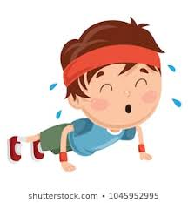 | 24  Student Choice!!  Choose any 3 exercises of your choice!! Challenge yourself and reach for 5 exercises!!  Repeat  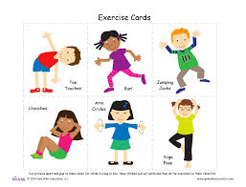 | 25  Stretching and Flexibility  Choose 5 stretches to complete.  Complete each stretch for 30-seconds.  Repeat  Click on Stretching and Flexibility document for examples.  
26  Outside  Get some fresh air. Take a walk, skip, run, ride your bike or play outside!  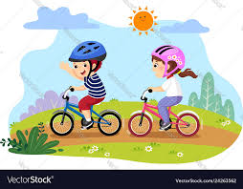 | 27  Leg Muscles  8 backward lunges  8 -12 calf raises  8 walking forward lunges  Repeat  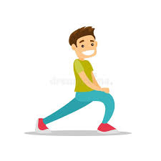 | 28  Core Muscles  8-12 crunches  15-30 second side plank  8-12 curl-ups  Repeat  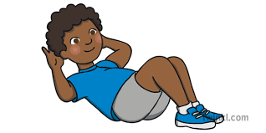 | 29  Cardio Day!  15-30 jumping jacks  30 second high knees  15 second Jump rope OR burpees  Repeat  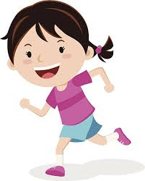 | 30  Upper Body Muscles  (Chest, Arms, Shoulders)  6-12 pushups  30 second arm circles  30 second shoulder shrugs  30 second neck roll  Repeat

